**Lab 2 : Google App Engine**

Name : Mugdha Wadikar

SJSU ID : 013768534

**Objective**:

This document contains step by step demonstration of Google App Engine registration, configuration, development environment preparation (Eclipse), sample project creation (using Google web toolkit) and deployment processes.

**Solution**:

I have deployed a basic Node.Js Application using npm package manager through google cloud app engine service.

The below tutorial shows a step - by- step methodology for creating the application and deploying it on cloud.

Here, one of the important points to remember is that Google cloud already creates an environment for the machine, so no installations are as such needed whereas on AWS , for the same application I had to install everything right from Git.

**Steps :**

1. Access Google App Engine to start with the assignment

Go to <http://appengine.google.com>

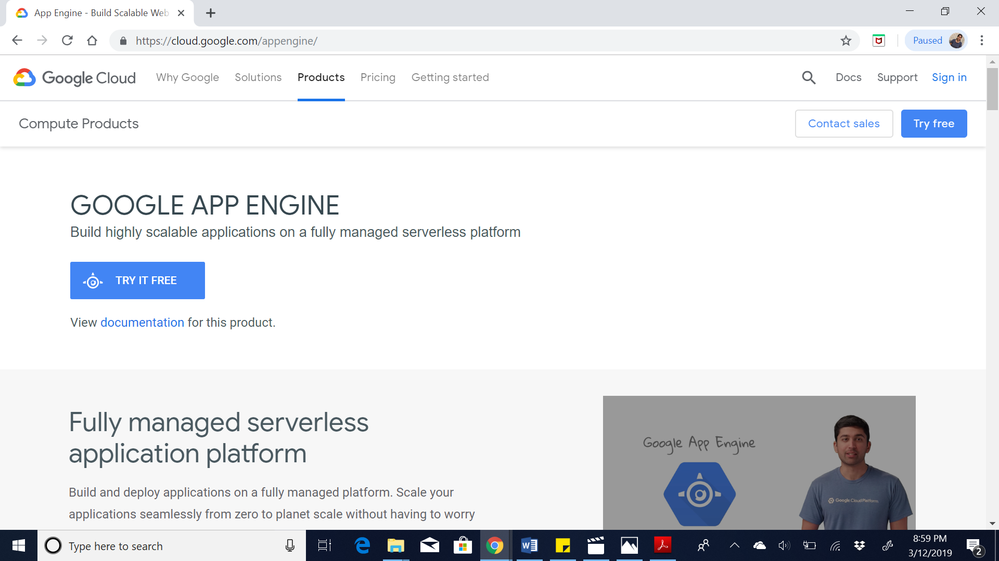

1. Login or create an account: I have already created an account, so I just logged in.

Access the console button as shown below.

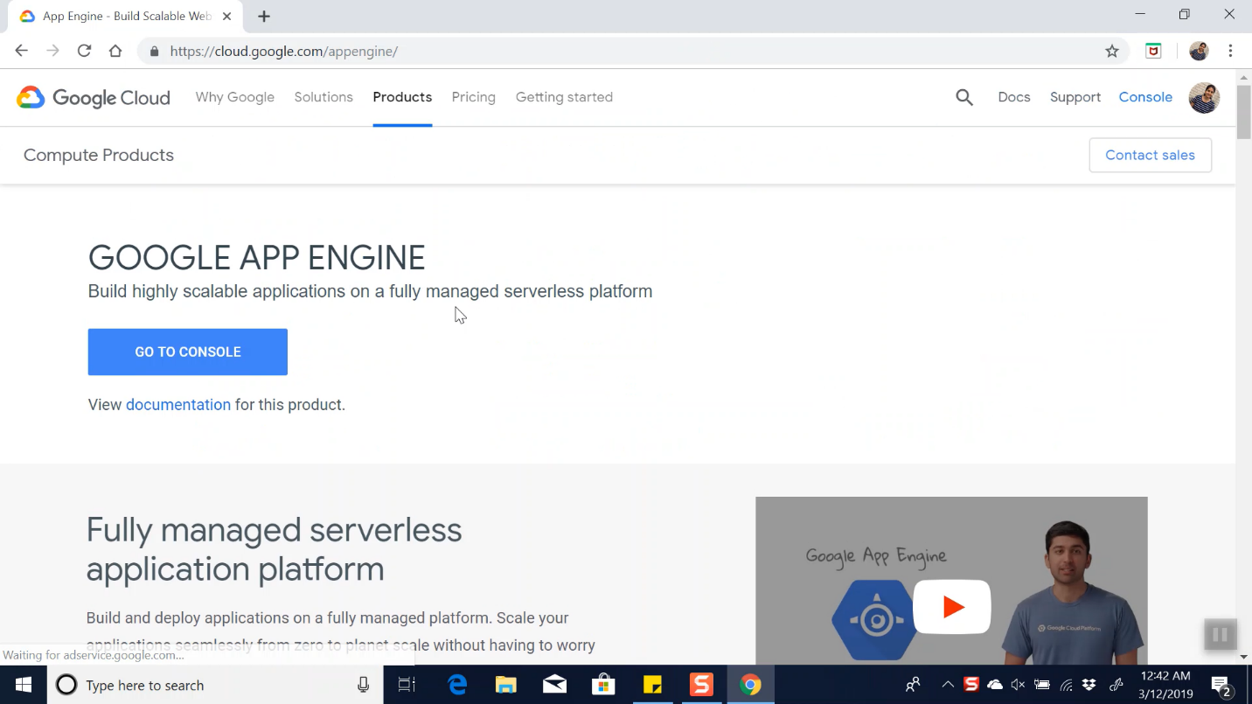

1. Once Logged into the console, it looks like this:

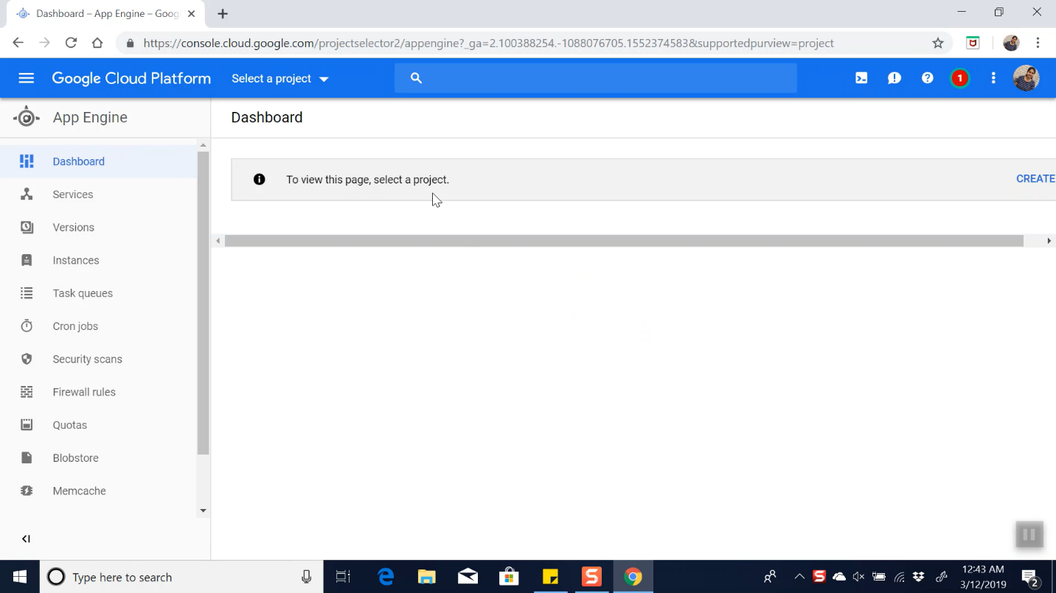

1. Create a new Project:

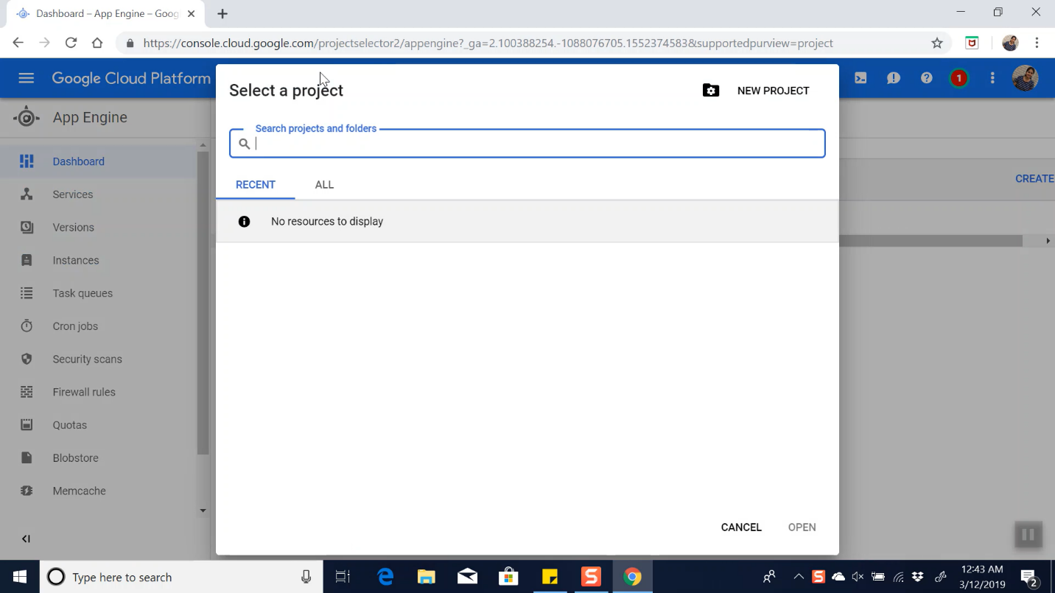

1. To start configuring the project, go to navigation menu

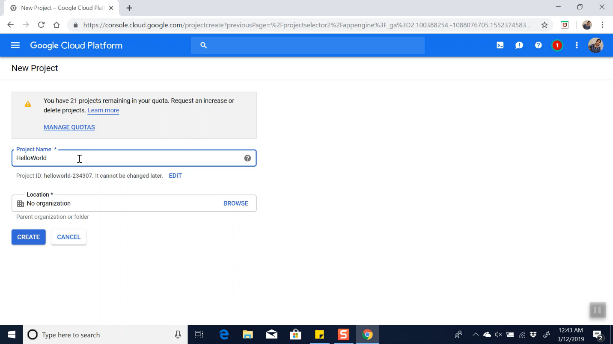

1. Open the google app engine console:

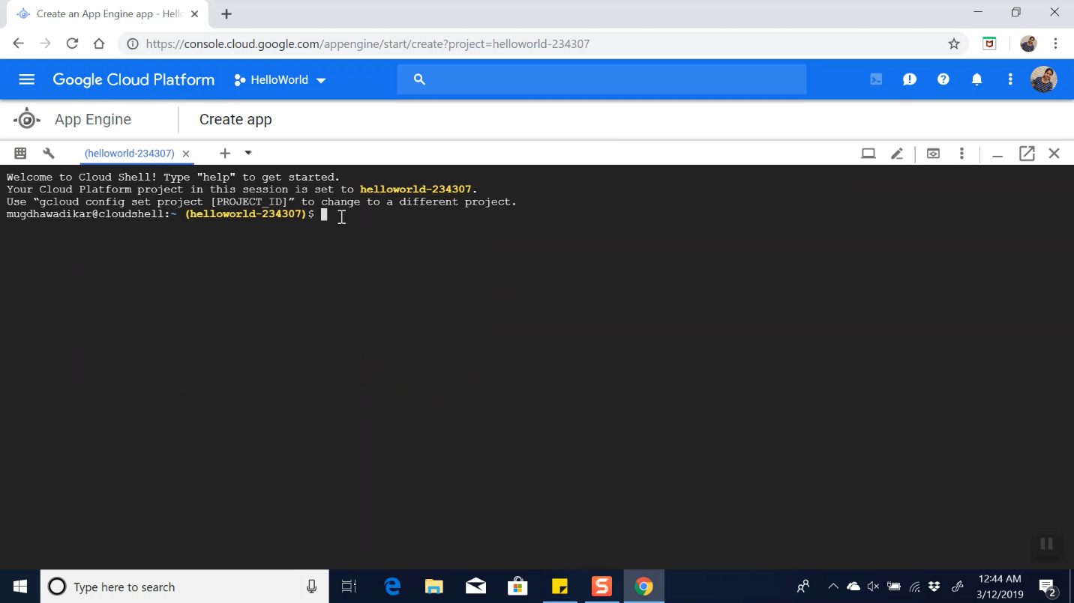

1. Clone the starter library and change path to 1-hello-world :

git clone https://github/com/GoogleCloudPlatform/



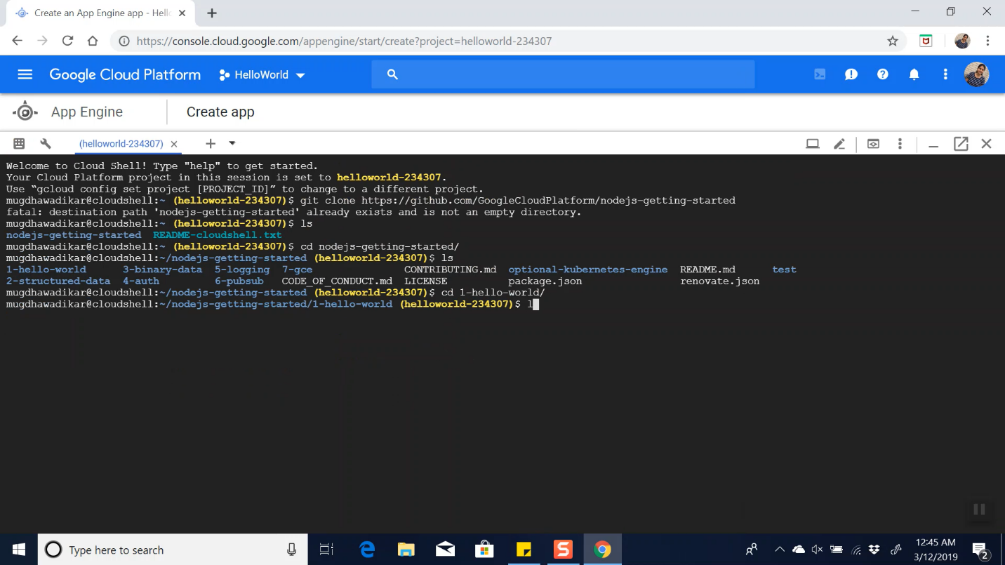

1. Use cat app.js to view the app.js file

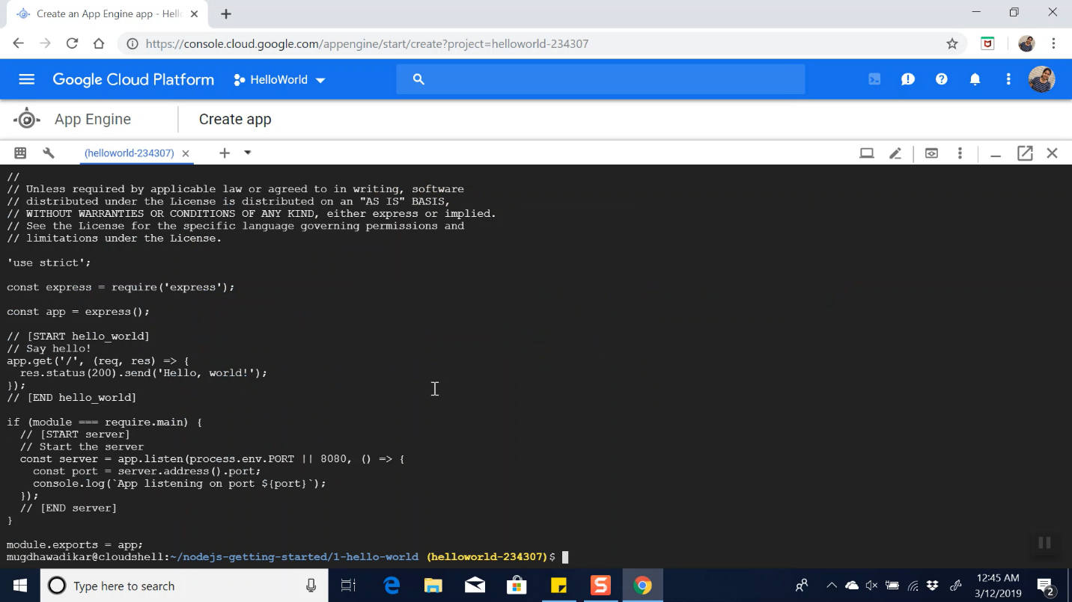

1. Use cat app.yaml to view the app.yaml file:



1. Export Port and Install npm

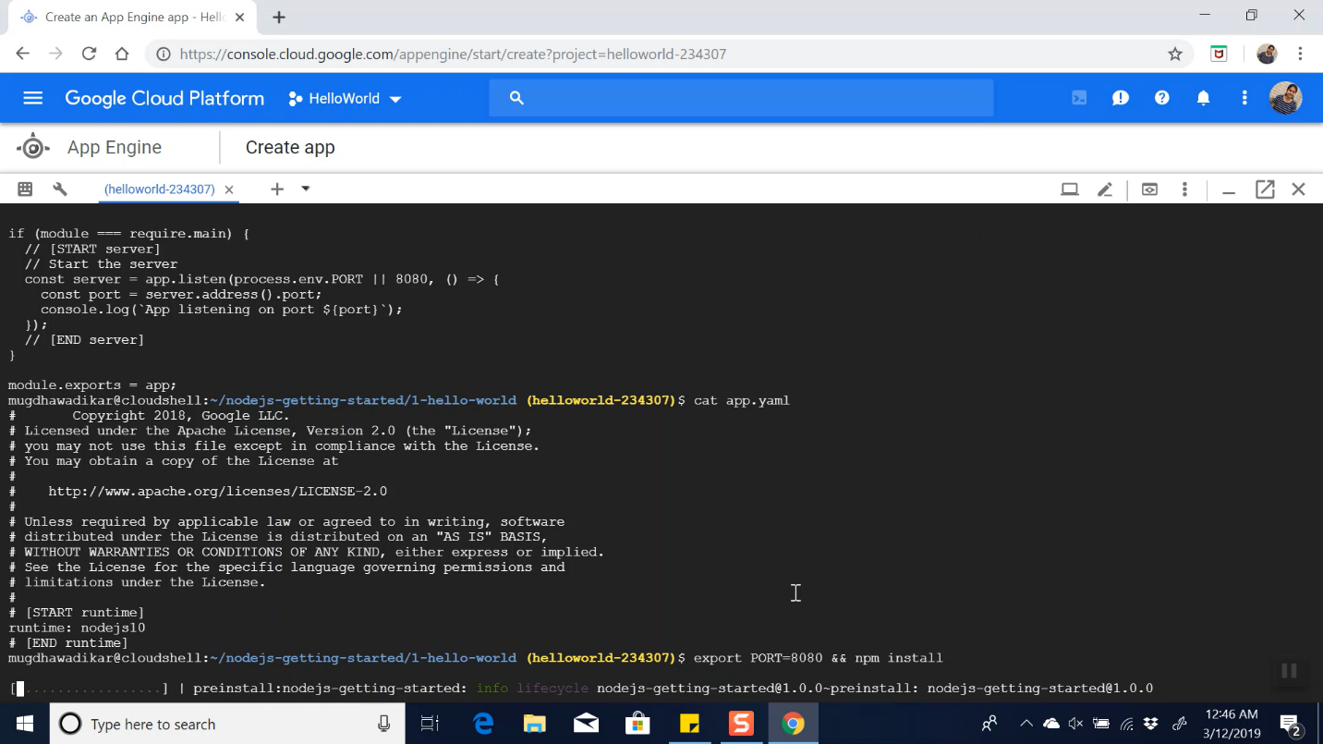

1. Use npm start command to start the app

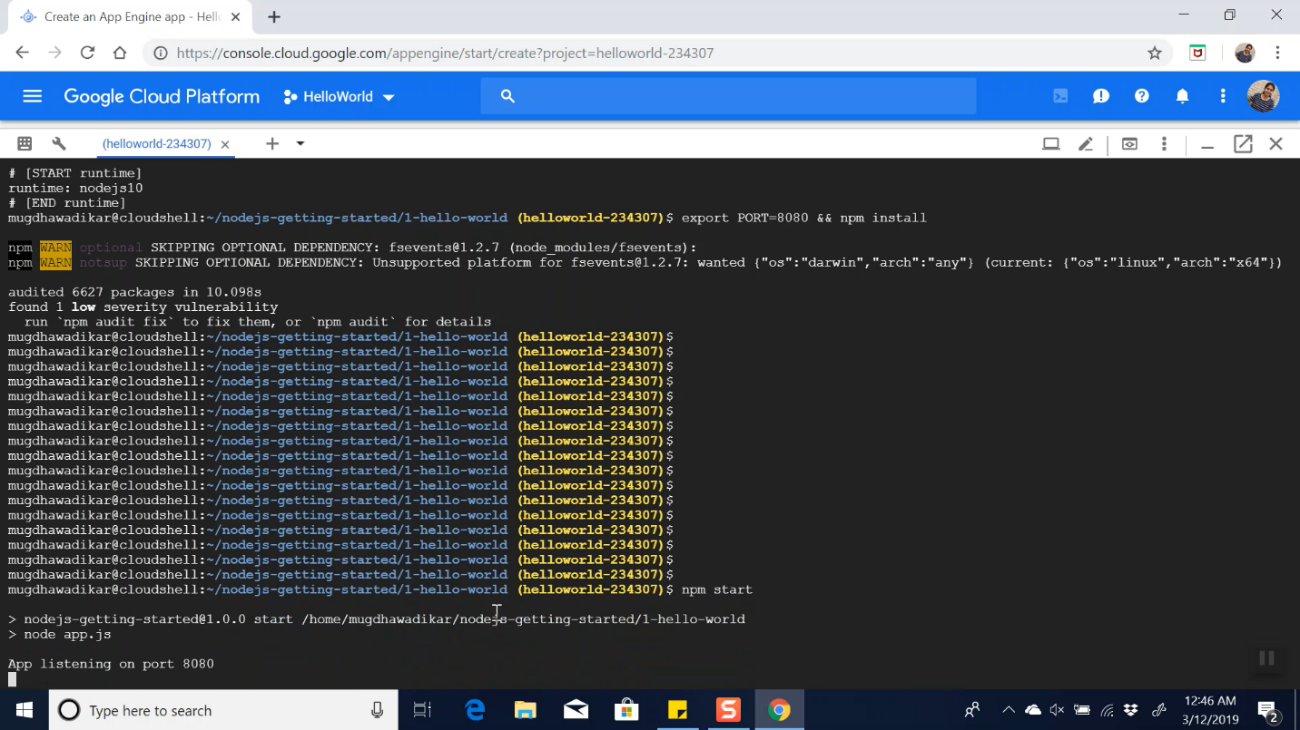

1. Create App Engine and select region/location for App engine deployment: gcloud app create

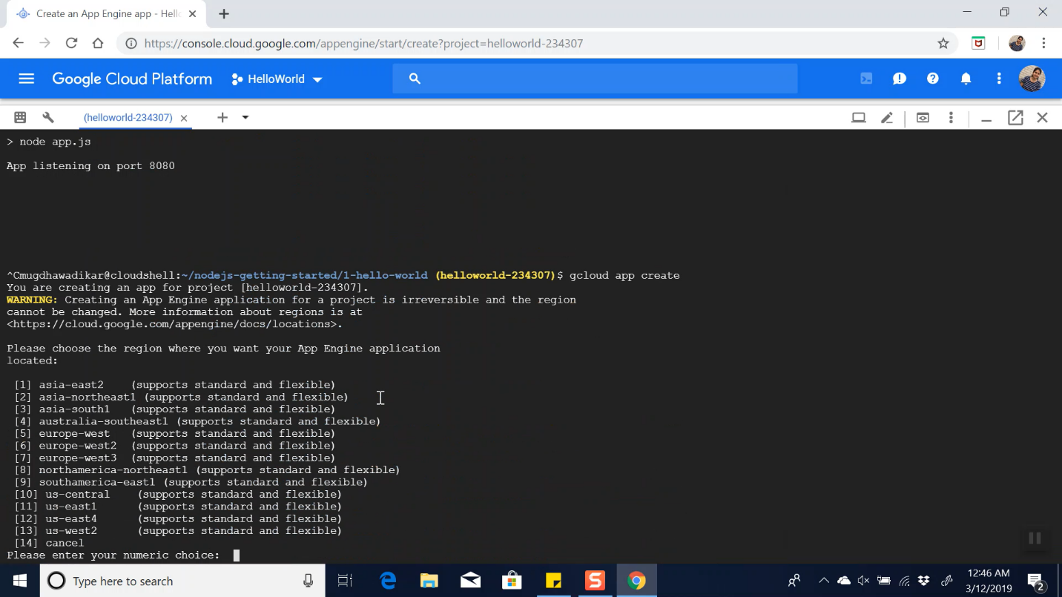

1. Select region number: 13

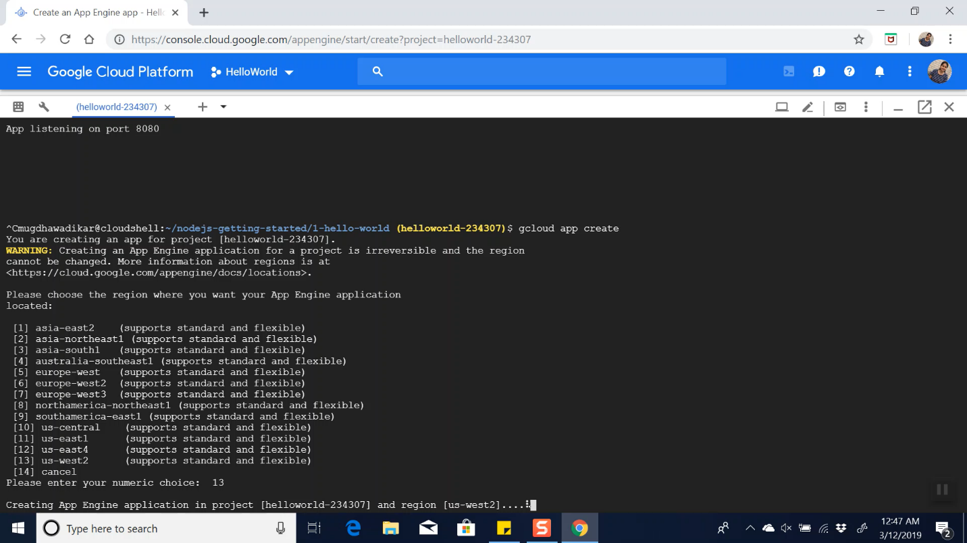

1. Deploy the app: gcloud app deploy

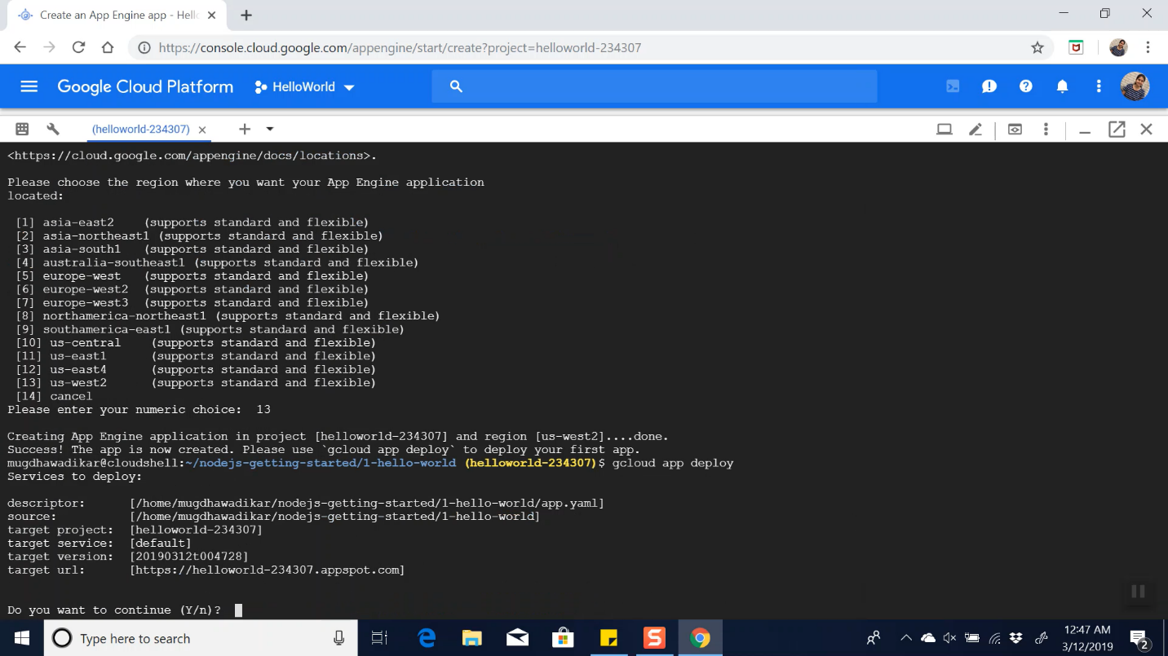

1. Press Y for confirmation:

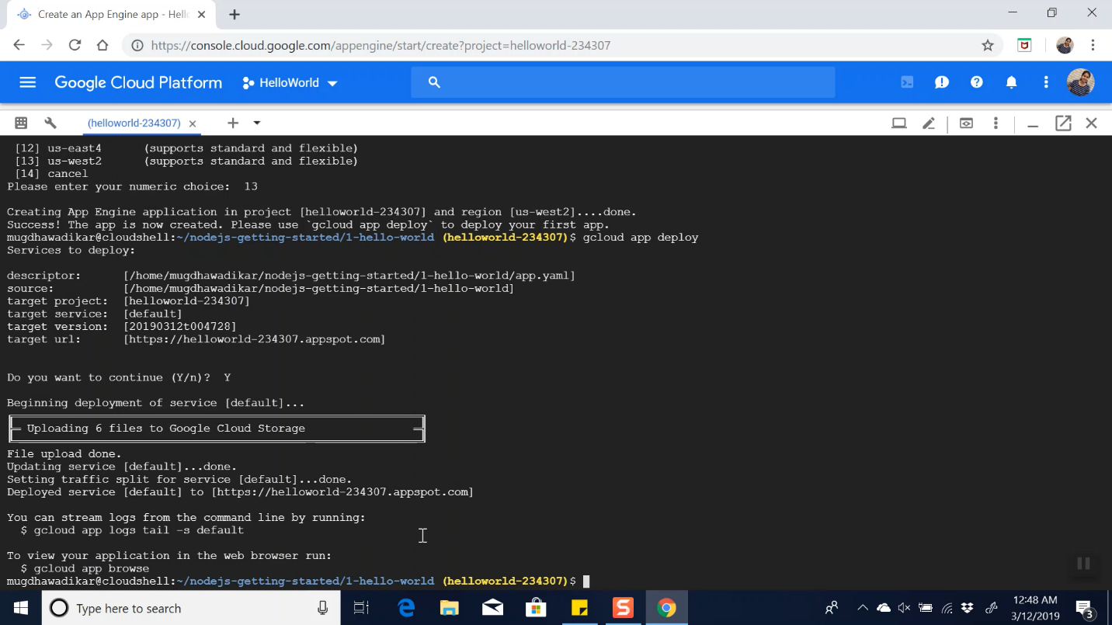

1. To browse the app on browser: gcloud app browse

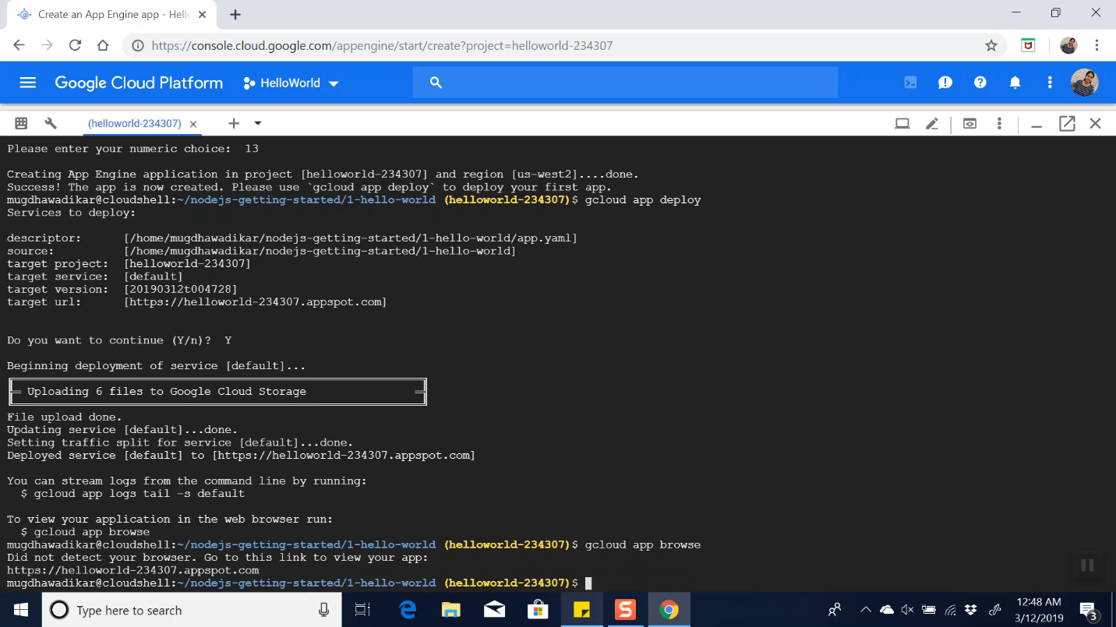

1. View the app in browser:

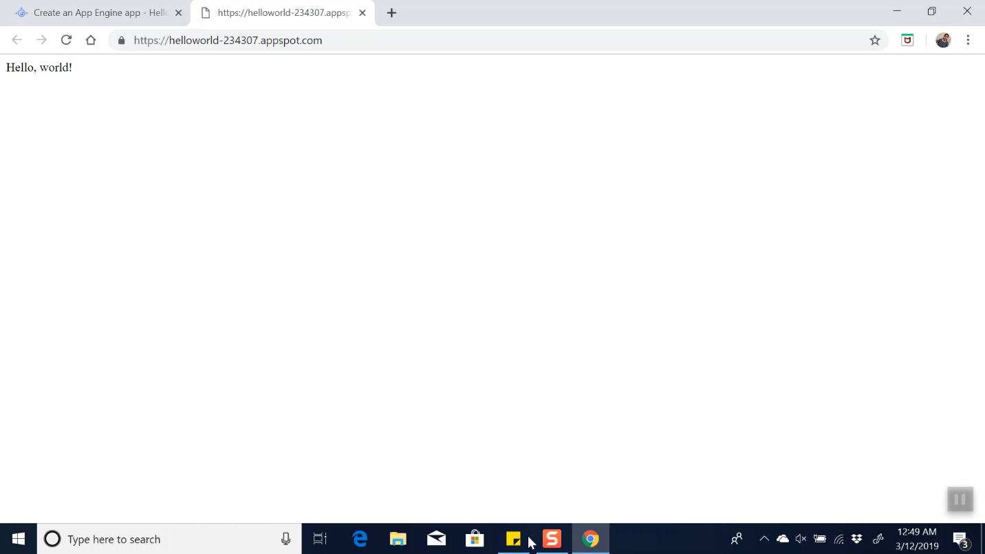

Thus, we have seen how to deploy a simple NodeJs app on Google App Engine